Southeastern
Actuaries Conference

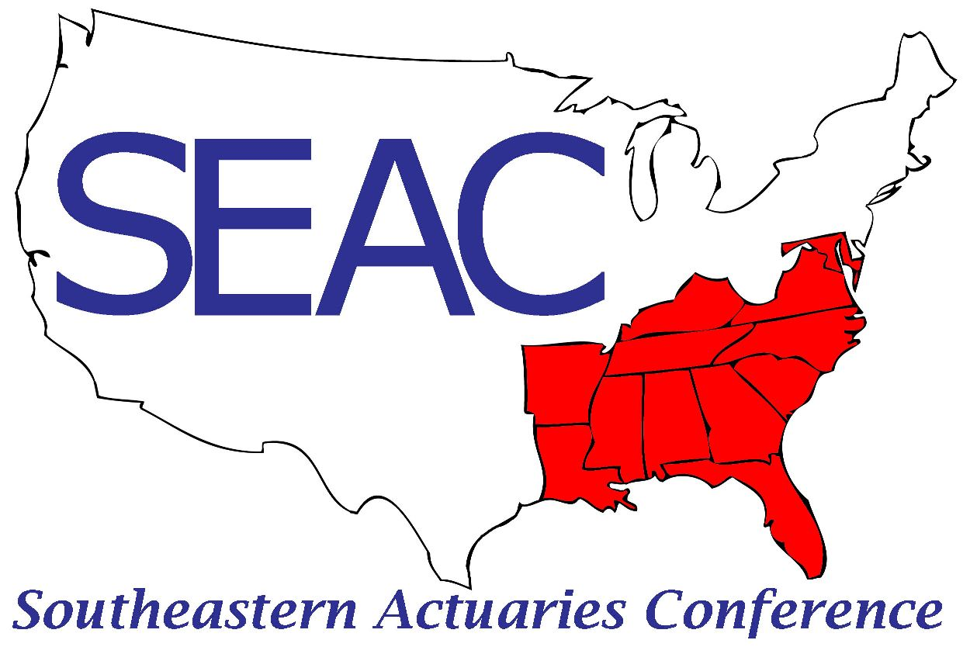

Spring Meeting
June 21-23, 2023

Sandpearl Resort

Clearwater, FL

Executive Committee

President | Woolford London
Vice President | John Condo
Secretary/Treasurer | Dave Rowbottom
Membership Chair | Mike Celichowski
Past President | Kareen Dorsett
Member at Large | John Gramelspacher
Member at Large | JoAnn Bogolin

Wednesday, June 21st – Pre-Meeting Seminars

1:30 p.m.–5:00 p.m. Registration [Hunter Foyer]

2:00 p.m.–5:00 p.m. Professionalism: A Foundation That Will Serve You Well! [Hunter A & B]
- Foundations of Professionalism that will serve you well in your career as an actuary
- What it means to be a “professional” actuary
- How practice standards are developed
- Keeping principles like self-regulation and clear communication will help you adhere to professionalism standards and shine in your professional role

Darrell Knapp, Willis Towers Watson
Tom Wildsmith, BlueCross, BlueShield

3:30 p.m.–4:00 p.m. Break Sponsored by Moody’s Analytics [Hunter Foyer]

5:30 p.m.–7:00 p.m. Vendor Reception Sponsored by Fortitude Re [Gulf Lawn]

Thursday, June 22nd

7:00 a.m.–12:00 p.m. Registration [Hunter Foyer]

7:00 a.m.–8:00 a.m. Breakfast [Hunter C]

8:00 a.m.–8:30 a.m. Business Session [Hunter A & B]

8:30 a.m.–10:00 a.m. General Session [Hunter A & B]

- Drivers of Mortality Improvement: SOA Research Spotlight
- In October 2022, the SOA sponsored Oliver Wyman’s research into mortality improvement to confirm the mortality improvement trends generally observed, identify how the improvement trends differ by socioeconomic subgroups, and identify cause of death drivers
- What makes the research unique was that it used individual record data (as opposed to county or ZIP Code data) from the US Census (with demographic data) matched up against death certificate information (with cause of death) for over 3.5 million records with nearly 500,000 deaths
- The results show a strong and growing divergence of improvement rates between affluence groups with direct implications for how companies should set improvement assumptions

Mark Spong, Oliver Wyman

- The Way AI and Predictive Analytics Impacts Life Insurance Carriers in the New Era
- ChatGPT, Generative AI, and how they relate to life insurance actuaries day-to-day work
- Gain a deeper understanding of how advanced AI models are built and why they are perceived as the main driver to pave the future of life insurance
- The role of actuaries in AI and data science for life insurance

Dror Katzav, Atidot

10:00 a.m.–10:30 a.m. Break Sponsored by Munich Re [Hunter Foyer]

10:30 a.m.–12:00 p.m. Concurrent Sessions

- Life Insurance [Hunter A]

- US GAAP LDTI – Overview and Early Observations (30 min)
- Accounting Standards Update 2018-12 (Targeted Improvements to the Accounting for Long-Duration Contracts or “LDTI”) was effective at the beginning of 2023
- This session will provide a brief overview of the changes
- We will share some of our emerging observations from transition period and Q1 2023 reporting

Sam Keller, WTW
Andrew Davis, WTW

- Is This Time Different: ALM in a Higher Rate Environment (30 min)
- 10yr and 30yr rates have "normalized" to decade highs, will they continue to go higher?
- Should ALM strategies be "different" in a rising rate and higher volatility environment?
- Should we be concerned about higher lapse risk? What are mitigating strategies?

Russell Gao, Fortitude Re

- Health and Combo Product Modeling Challenges and Solutions (30 min)
- This session will address the unique challenges of modeling complex health and life-health-combination products, and explore solutions

Jesse Resnick, Moody’s Analytics

2. Health Insurance [Hunter B]

- Inflation Reduction Act – Beyond the Obvious (30 min)
- Basic Intro – The major provisions of the act that apply to Medicare Part D
- Drug Negotiation – Which Drugs in 2026/2027? Impacts to Formulary. Impacts on Trend? New Drug Release Pricing. Rebates.
- Inflation Caps – Projected impacts in trend. Impacts to new drug release pricing
- New Benefit Design Questions – What does an EA plan look like in this new environment? Risk adjustment? Insulins/Vaccines – Market has already reacted

David Walters, Wakely

- SOA Pharmacy Partnership Forum: Reimagining Pharmacy Financing (30 min)
- Defining Value
- Measuring Value
- Applying the answers

Greg Warren, Axene Health Partners

- AAA Health Equity Committee - Gearing up for Symposium
- What's actuarial about health equity?
- Summer workshop series and Fall Symposium

Stacey Lampkin, Independent Living Systems

12:00 p.m. Networking

6:30 p.m.–7:45 p.m. General Reception (Beverages sponsored by DW Simpson) [Gulf Lawn]

Friday, June 23rd

7:00 a.m.–8:00 a.m. Breakfast [Hunter C]

8:00 a.m.–8:10 a.m. Business Session [Hunter A & B]

8:10 a.m.–10:00 a.m. General Session [Hunter A & B]

- Role of Life Underwriter in the Collaboration Between Underwriters and Actuaries
- How to better understand each other’s language
- What does an Underwriter do and why?
- What effect does accelerated underwriting have on this collaborative relationship?

Kent Karnick, LifeScore Labs

- AI, Large Language Models and ChatGPT
- Brief overview of Large Language Models (LLM) and ChatGPT- including how they work and how they can improve the way we work

Svetlana Bender, GuideWell/Florida Blue

- Mental Well-Being and Flourishing - Our New North Star
- Definition of Mental Well-Being
- Measurement of Flourishing
- Economics of Mental Well-Being

Nick Dewan, GuideWell/Florida Blue

10:00 a.m.–10:30 a.m. Break Sponsored by Canada Life Re [Hunter Foyer]

10:30 a.m.–12:00 p.m. Workshops

- Life Topics [Hunter A]
  - John Condo:

- Health Topics [Hunter B]
- Stu Rachlin:

12:15 p.m. Adjourn

Future SEAC Meetings
The DeSoto | Savannah, GA | November 16-18, 2023
Opal Grand Resort | Delray Beach, FL | June 19-21, 2024*
The Whitley Atlanta Buckhead | Atlanta, GA | November 20-24, 2024
Hyatt Coconut Point | Bonita Springs, FL | June 10-12, 2024
* 75th Anniversary

SEAC Appreciates our Sponsors

