# ***Southeastern***

***Actuaries Conference***

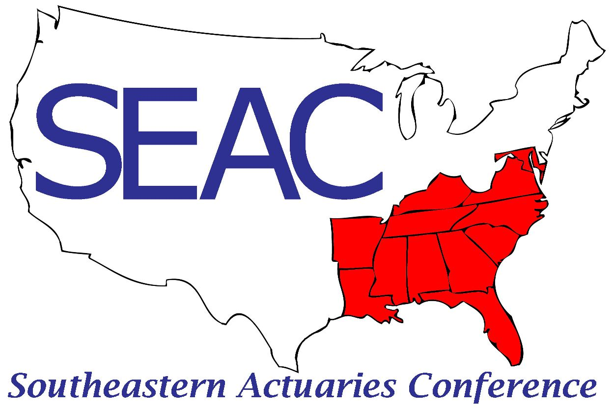

**Spring Meeting**

**June 19-21, 2024**

**Opal Grand Oceanfront Resort**

**Delray Beach, FL**

**Executive Committee**

|  |  |
| --- | --- |
| *President* | *John Condo* |
| *Vice President* | *Mike Celichowski* |
| *Secretary/Treasurer* | *Dave Rowbottom* |
| *Membership Chair* | *John Gramelspacher* |
| *Past President* | *Woolford London* |
| *Member at Large* | *JoAnn Bogolin* |
| *Member at Large* | *Pamela Laboy* |

***Wednesday, June 19th – Pre-Meeting Seminars***

1:30 p.m.–5:00 p.m. ***Registration [Seacrest Foyer]***

2:00 p.m.–5:00 p.m. **Tools and Rules for Understanding and Maintaining Ethical Practice [Salon EF]**

In this program, leading professionalism volunteers from the American Academy of Actuaries will explore how ethical actuarial practice and the fulfillment of professional responsibilities are supported by the Code of Professional Conduct, the actuarial standards of practice (ASOPs), and other resources developed and maintained by our self-regulating profession. This compelling session will explore the ultimately ethical foundation of our commitment to professionalism, and how ethical thinking and resources like discussion papers recently developed by the Academy’s Committee on Professional Responsibility can support you in shining as a professional.

***Ken Kent, American Academy of Actuaries Immediate Past President***

***Melissa Zrelack, Academy Committee on Professional Responsibility member***

3:30 p.m.–4:00 p.m. ***Break Sponsored by Moody’s [Seacrest Foyer]***

5:30 p.m.–7:0 p.m. ***Vendor Reception Sponsored by Fortitude Re [Seacrest Foyer]***

***Thursday, June 20th***

7:00 a.m.–12:00 p.m. ***Registration [Seacrest Foyer]***

7:00 a.m.–8:00 a.m. ***Breakfast [Salon D]***

8:00 a.m.–8:30 a.m. ***Business Session [******Salon EF]***

8:30 a.m.–10:00 a.m. ***General Session [Salon EF]***

* ***Predictive Analytics: The Convergence of Data Science and Actuarial Practice***

The growing need for competitive pricing and enhanced business efficiencies require the modern actuary to augment traditional methods and techniques with more advanced analytics and automation into their everyday practice. During this session, we will explore a few of the areas where we can gain a competitive advantage by leveraging data science into our traditional actuarial practices.

***Justin Fountain, WTW***

* ***The Future of Gene Therapy - Innovative Treatments and Funding Challenges***

After an introduction to gene therapy treatments and a look at the incredible impact gene therapy treatments are having for beneficiaries, we will examine gene therapy drugs currently on the market and in development, the cost of these drugs, and how health plans are preparing for these impacts.  Gene therapy drugs can change lives for the better, but are we prepared to provide these treatments and pay for them?

***Danny Moore, Lewis & Ellis***

* ***Retiree Medical Reimbursement Plans***

Discussion of the basics of modeling a Retiree Medical Trust (RMT), including common provisions and parameters.  We will walk through the why and how, as well as some examples of RMTs.

***Greg Stump, Boomershine Consulting***

10:00 a.m.–10:30 a.m. ***Break Sponsored by SOA Financial Reporting Section [Seacrest Foyer]***

10:30 a.m.–12:00 p.m. ***Concurrent Sessions***

1. ***Life Insurance [Salon E]***

* ***LDTI Day 2***

***Nathan Worrell, Moody’s***

* ***Model Build Lessons Learned***

Change is inevitable in the life actuarial modeling world as blocks of business are acquired or reinsured, new products are onboarded, and regulatory updates emerge. Modeling solutions of those changes are seen as successful when they are accomplished within leadership or external constraints, accurate, and efficient to maintain as part of business as usual work. This presentation will focus on lessons learned from major model changes through modeling leadership roles at two different companies including onboarding seven deals, merging reserving and projection functionality, adding LDTI modeling, coding new and re-priced products, and a valuation modeling platform conversion. We will explore the following key themes:

* Effective cross-departmental collaboration
* Consideration of process and scale
* Focus on review and controls

***Valerie Smeshko, Fortitude Re***

* ***Indexed UL Assumptions – Learn from the UL Lessons of the Past***

IUL continues to be the most popular UL product with sales reaching $1B in Q4 2023, according to LIMRA. There is little long term experience for IUL and many companies value and model IUL just like UL, but there are material potential differences that need to be considered for valuation and projection purposes. Presenters will discuss key risks and differences between IUL and UL relating to policyholder behavior and how to value, project, monitor and manage those risks to avoid repeating misestimates of the past. Presenters will also discuss broader life assumption risks such as mortality and YRT reinsurance risk. Attendees will learn about options on how to potentially address underperforming blocks of IUL and will obtain an improved perspective on the risks of IUL products and the differences versus UL and how to incorporate these differences into their valuation and projection exercises.

***Nik Godon, WTW***

***2. Health Insurance [Salon F]***

* ***Risk Sharing Arrangements in an Ever-Changing MAPD World***

With the passage of the Inflation Reduction Act in 2022, the MAPD program is due to undergo some of the biggest changes since the addition of Part D. In addition to the significant Part D IRA re-design, the Centers for Medicare and Medicaid Services (CMS), is moving forward with increased scrutiny on plan designs and supplemental plan benefit offerings, including for chronically ill (though SSBCI) and low-income (through VBID) Medicare beneficiaries. In the midst of it all, Medicare Advantage Organizations have put additional focus on maximizing and expanding on existing provider risk sharing arrangements to continue offering value to their members. Our presentation looks at some of the latest MAPD regulations and the impact on Risk-Sharing Arrangements for Plans, Providers, and Payments in 2025 and beyond.

***Jim Cooper, Milliman***

***Jeff Grover, Complete Health***

* ***Trends in Medicare Advantage***

Medicare Advantage is changing rapidly due to natural growth of the program as well as due to legislative and regulatory changes. This presentation will explore many of those changes including membership growth, trends in Medical and Pharmacy costs, supplemental benefit offerings, and observations from the 2025 bid pricing season.

***Robert Lang, Wakely***

* ***Enterprise Restructuring in Health Industry***

***Anthony Beato, Guidewell***

12:00 p.m. ***Networking***

6:30 p.m.–7:45 p.m. ***General Reception (Beverages sponsored by DW Simpson) [Ocean Terrace]***

***Friday, June 23rd***

7:00 a.m.–8:00 a.m. ***Breakfast [Salon D]***

8:00 a.m.–8:10 a.m. ***Business Session [Salon EF]***

8:10 a.m.–10:00 a.m. ***General Session [Salon EF]***

* ***Generative AI for Insurance Automation***

Insurers are moving quickly to gain efficiencies by lowering their costs through Gen AI automation.  Better understand Gen AI and the use cases helping Insurers improve underwriting and claims outcomes though lessons learned and live simple demos that show case the value insurers are seeing from this emerging technology.

1) Generative Artificial Intelligence (Gen AI) Overview

2) Insurance Automation and Demo

3) Gen AI Governance;

4) Where to Start

***David Moorhead, EY***

* ***Model Risk Management from the Bermuda (BMA) Perspective***

In 2023, the Bermuda Monetary Authority (BMA) released consultation papers that significantly emphasize enhanced risk management and governance practices. This presentation will discuss the key components of these regulatory changes and their impact on risk management frameworks. Additionally, we will explore the scope of the new MRM view, covering everything from asset holding and administration files to BMA submissions. The session will include a detailed look at the SBA (Scenario-Based Approach) process, providing valuable insights through practical illustrations.

***Alla Shved, Fortitude Re***

* ***There Goes the Neighborhood: A review of federal health coverage regulatory actions of 2023 and 2024***

Federal regulators oversee the majority of the U.S. health care and coverage landscape. In this session, we will explore some of the major regulatory actions shaping health markets in 2024 and 2025 as well as some of the dynamics already shaping health policy discussions for 2026 and beyond.

***Jason Karcher, Milliman***

10:00 a.m.–10:30 a.m. ***Break Sponsored by TBD [Seacrest Foyer]***

10:30 a.m.–12:00 p.m. ***Workshops***

1. ***Life Topics [Ocean Breeze]***
   * Moderator- Mike Celichowski, Fortitude Re
2. ***Health Topics [Salon D]***

* Moderator- Wendy Windsor, Gallagher Re

12:15 p.m. ***Adjourn***

***Future SEAC Meetings***

|  |  |  |
| --- | --- | --- |
|  |  |  |
| Whitley Atlanta Buckhead | Atlanta, GA | November 20-22, 2024* |
| Hyatt Regency Coconut Point Resort  The Ballantyne | Bonita Springs, FL  Charlotte, NC | June 10-12, 2025  November 19-21, 2025 |
|  |  |  |
| * 75th Anniversary |  |  |

***SEAC Appreciates our Sponsors***

**PLATINUM**

**GOLD**

**SILVER**

